If the measurement setup is not stationary it will most likely result in a not stationary process. That means the probabillity might shift between offset curves as seen here:

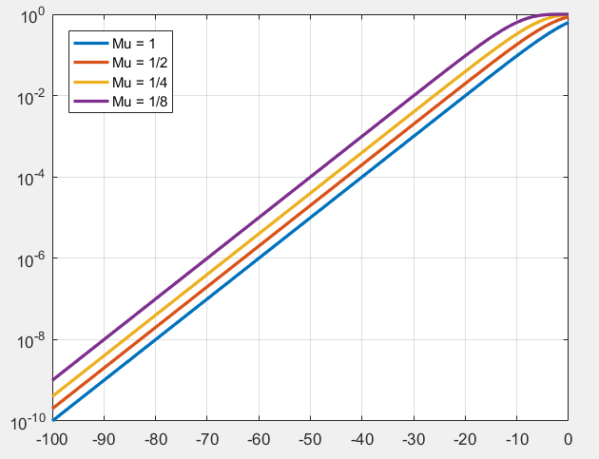

However as the by looking at the measurements points a different way it can also be expressed in the complex plane as: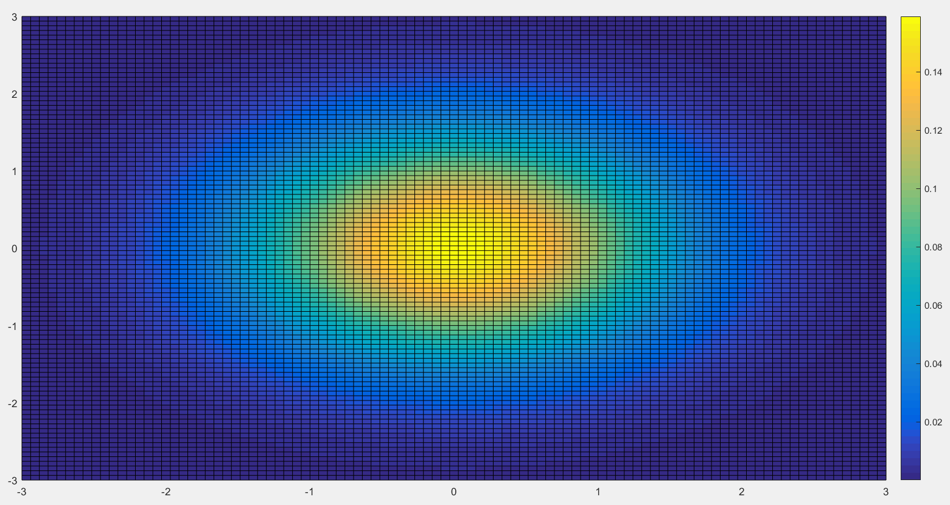

To then find the CDF as seen before an aerial integration should be performed.

From this perspective, it seems unlikely that an unexpected situation should occur at zero, which will result in the extension of models not being correct.

However when the measurements have been performed a PDF/CDF of the points can be made. Then different models can be tested such as:

$$P_{\left|H\right|}=a_{0}+a_{1}*r$$

By finding the maximum likelihood estimate of $a_{0}$ and $a_{1}$ it can then be determined if the factor is important or not.

NB:

This is a method to treat the data afterwards it still requires the measurements